PROGRAM 8: Alpha Beta Pruning
Code:
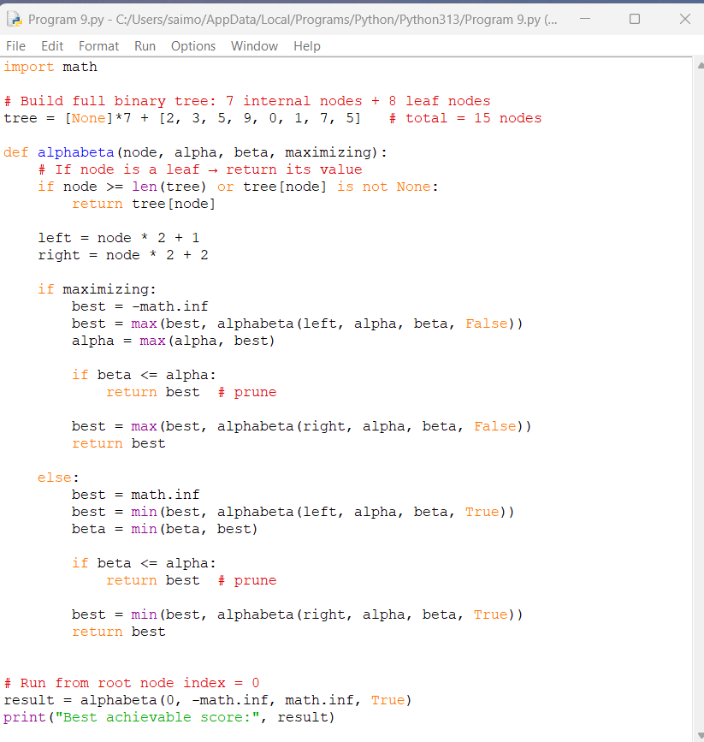

Output:
